**Effective Site Response Analysis**

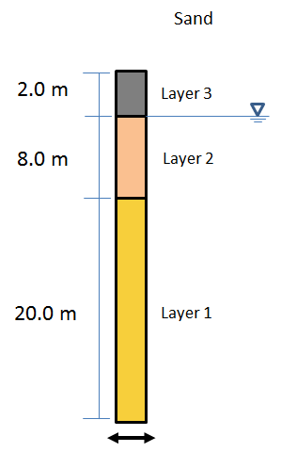

**Procedure**

1. Run opensees

*opensees <freeFieldEffective.tcl 2>LOG 1>OUT*

1. Postprocess results and create plots using matlab or python (run as a batch job)

*matlab –nosplash –logfile “file.log” –minimize –r “accelPlot.m; exit”*

1. Create report using latex/word or other word processor

*pdflatex ShortReport.tex*